4 Magmatism and Volcanoes Activity

Magmatism is a complex of geological processes, which has the driving force magma and its derivatives. Magma (Greek magma – thick cream, dough) – nature high-temperature silicate melt, saturated with gaseous products and formed in the form of individual foci in the lithosphere (mainly in the asthenosphere). By the introduction of magma in the earth crust or its outpouring on the surface of the Earth igneous rocks are formed.
Thermodynamic equilibrium specific for different depths is set inside the Earth, providing a solid state of matter. Any violation of this balance (inreasing of temperature or decreasing of pressure) is usually accompanied with transition of solid to liquid. Rise of temperature may be associated with radioactive phenomena, and pressure decrease – with tectonical processes. Thus, magmatism is deep processes, caused by thermal and gravitational fields of the Earth.
According to experimental data and results of mineral composition study of magmatic rocks, temperature of magmatic melt is within 700–1200^{о}С and higher. Volatile components (water vapor and gas - H2S, H2, CO2, HCl, etc.) present in magma in the dissolved state, ensuring its viscous and moving state at great depths at a rather low temperature. In conditions of high pressure volatile content can reach 12%, they are chemically very active and mobile agents.
Depending on the nature of magma movement there are two types of magmatism: intrusive (deep) and effusive (sufrace). In both cases, during the solidification of molten magma igneous rocks and minerals, associated with them, form.
Intrusive magmatism (plutonism)
The movement of magma ends within granite or sediment layer at deep magmatism. Process of the introduction of a magmatic melt into the formation of the crust is called intrusion (from the Latin intrusion – pushing, introduction). Magma, solidifying, forms magma body, also called intrusion.
As remove of magma from the depths (according to experimantal data areas of magma formation are between 15 and 250 km) to upper horizons of earth crust, it enters the conditions of relatively low temperature and pressure. By lowering the pressure and temperature various minerals fall in sequence of magmatic melt.
Up to700^{о}С most refractory anhydrous minerals (olivine, pyroxene, nepheline, apatite, feldspar, etc.), and also ore minerals (pyrrhotite, magnetite, pentlanit, ilmenite, native platinum, etc.) first begin to crystallize. In the range of temperatures 600–400^{о}С specific rocks – pegmatites form. According to А.Е. Fersman, there are more than 280 minerals in granite pegmatites. Part of them has great practical interest, as it contains such elements as niobium, tantalum, lithium, beryllium, rubidium, cesium, rare earths group, etc.
In the end of magmatic process, after the significant part of melt has already been crystalized, when the melt temperature is lowered to 500–350^{о}С may coexist gas and liquid. These solutions are called gas-water or pneumatolytic-hydrothermal (Greek pneuma – gas, hydro – water). They contain many volatile components, such as H₂O, F, Cl, CO₂ and etc., which are carriers of mineral-ore-forming substances and therefore are called mineralizer.
As a result of crystallization of magma igneous intrusive rocks form, characterized by chemical and mineral composition, structure and texture, shape bodies.
Deep of solidification, structure and texture. Intrusive rocks form at various depths of earth crust in conditions of high pressure and slow cooling. Depending on depth of solidification there are deep (abissal – formed at depths, reaching few kilometers and deeper) and hypabyssal. Various conditions of formation reflect on structure and texture of intrusive rocks.
In conditions of slow cooling holocrystalline structure formed in rocks in the whole, which is depending on specific conditions may be characterized by varying degrees of crystallinity, size and shape of mineral grains.
Texture of intrusive rocks differs by much less diverse. Rocks in the whole are dense, compact – it emphasizes their formation under high pressure. There are homogeneous (massive), schlieren (spotted or taxitic) and striped. Compact massive texture is the most widespread.
Shapes of intrusive arrays are different (fig. 5.1, 5.2 and 5.3).
Depending on depth of forming intrusive arrays are divided into subsurface, or subvolcanic (the last word means, that magma is almost came up to the surface, but still did not come out on it, ie, formed "almost Volcano" or subvolkano) – from a few hundred meters to 1.0-1.5 km; midwater or hypabyssal - up to 1-3 km deep or abyssal - deeper than 3 km.
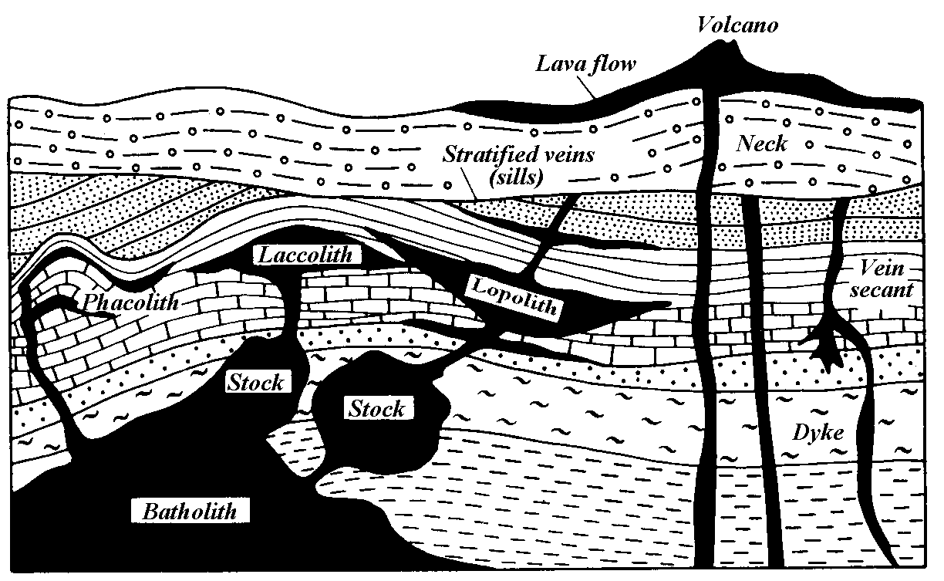
Fig. 5.1. Forms of occurrence of magmatic rocks
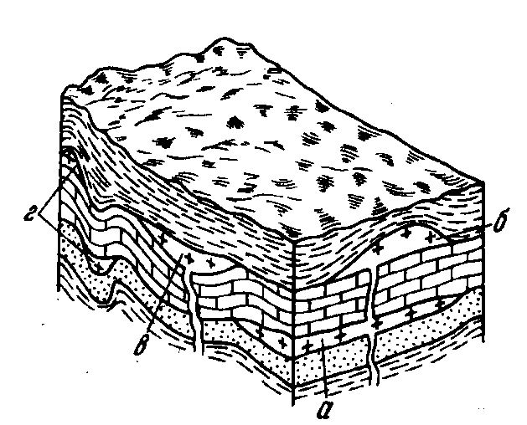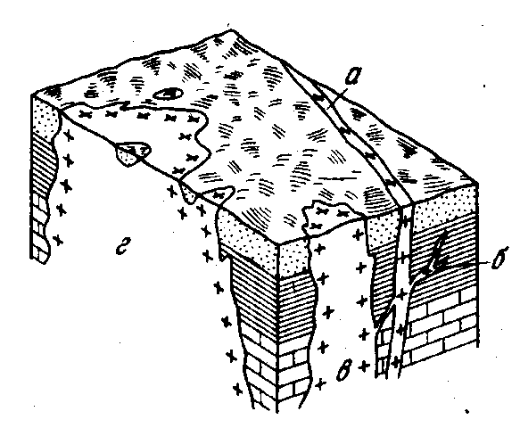
Fig. 5.2. Concordant intrusive bodies: Fig. 5.3. Discordant intrusive bodies:
а–sill; б–laccolite; в–lopolite; г–phacolithes а–dyke; б–vein; в–stock; г–batholith

Abridged view of the classification of the intrusive bodies of the American geologist R.O. Daly, received by academician A.N. Zavaritskii (1965):
А. Injection (lat injection – throw-in) arrays.
I. Concordant (конкордантные) injections (by layering planes):
1) sheetlike intrusive body or sills (Eng. sill).
2) laccoliths (Greek laccos – pit, dungeon);
3) факолиты (Greek faccos – lentil);
4) lopoliths (Greek lopas – bowl, dish);
II. Dissenters injection (timed to the secant cracks):
- dikes, veins (Scott. dike – wall);
- жерловины and necks (Eng. neck);
- ring and cone bodies;
- бисмалиты (Greek. bisma – bung);
- хонолиты (Greek. honevo – pouring out).
Б. Dissenters (discordant) deep arrays:
1) stocks (Germ. stock – shelf, trunk);
2) batholiths (Greek. batos – depth).
Intrusive bodies have various sizes. The largest of them are batholiths. They cover an area of hundreds of thousands of square kilometers, have elongated oval shape in plan. As a rule, batholiths are confined to the central parts of mountain-fold structures and composed of rocks of granitic composition. Vertical sizes (thickness) of many batholiths does not exceed 5–10 km. Lying among the host rocks of different composition (or rocks of intrusive frame), they have diverse, often irregular shape, limited laterally intrusive contacts, from the top - the roof, or the apical surface (fig. 5.4).
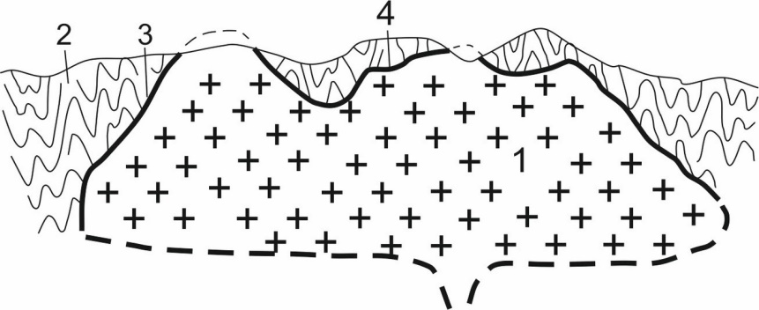
Fig. 5.4. Structure of intrusive bodies: 1 – intrusive massive (pluto); 2 – intrusion frame (host rocks); 3 – side contact; 4 – roof (apical surface)

Stocks – intrusive bodies of irregular shape, sectional area of which is not more than100 km². Often, stocks are offshoots of larger batholith, but often form subsurface body. (fig. 6.1).
Dikes are flat plate-like body, resulting magma filling the vertical and inclined cracks in the earth's crust. Dikes are composed of rocks of different composition and typically are arranged in groups. Sizes of dikes vary very widely. Many dikes have hundreds of meters long (sometimes a few kilometers), the thickness is a few meters.
Magmatic veins differ from dikes by uneven winding contacts, often have branching shape in plan and vertical sectional.
Effusive magmatism (volcanism)
In crushing the earth's crust and the formation of faults above the magma chamber, magma rises rapidly on them and poured on the surface of the Earth. The most striking manifestation of the surface magmatism is volcanic (Volcano – Romans’ god of fire у римлян). The magma often freed when volcanic eruptions from the bulk of dissolved volatile components (water vapor and gases) and is called lava (Ital. lava – flooding).
With the outpouring of magma on the surface volcanoes are formed– cone-shaped or dome-shaped hills. Process of eruption can proceed peacefully, but more often it is accompanied by powerful explosions. Formation of volcanoes occurs as a result of repeated periodic eruptions, sometimes resulting in a quiet outpouring of lava or explosion.
Volcanoes are: land and underwater; ancient and modern; extinct and existing. Currently, the land has about 700 active volcanoes and extinct several thousand operated in past geological epochs. Number of underwater volcanoes is almost impossible to count - only in the Pacific Ocean may have more than 10 thousand.
Types of volcanic apparatus. By the nature of the space occupied by the rising magma, volcanoes are divided into areal, fissure and central. Areal volcanoes existed only in the very early stages of the Earth's history, when earth crust was thin (and in some areas it could melt completely) and the outpouring of magma occurred over vast areas. Practically areal volcanoes are seas of molten lava.
Fissure volcanoes are lava flows on the extended cracks. Volcanism of fissure type in certain periods of time reached a very broad scale, with the result that a huge amount of volcanic material handed down to the surface of the Earth. For example, in the Devonian period, almost the entire territory of Central Kazakhstan was flooded with lava fissure eruptions with central hearths. At the present stage fissure volcanoes are spread limited, although they are occurred in some areas, for example, volcano Laki in Iceland, Tolbachik on Kamchatka, etc. There is not central exhaust opening in the volcanoes of fissure type and lava poured on the surface through deep, long cracks in the earth's crust. As a result powerful covers лавоносные form.
In volcanoes of central type, representing the geological structures in the form of cone-shaped mountains, eruptions occur through a central outlet port (fig. 5.5). Each volcano has vent, i.е. excretory channel through which eruptions products rise from the magma chamber, and crater – a cup-shaped recess located on the top of a mountain, and as an upper end of the vent. The side exhaust vents, called parasitic volcanoes branch out of many large volcanic crater.

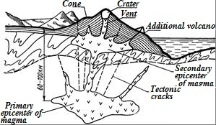
Fig. 5.5. Scheme of structure of volcanic apparatus of central type and feeding foci

With the destruction of the vertices of the cones as a result of volcanic explosions or dips in their place may form vast depressions (up to 15 km in diameter), rounded shape, which are called calderas. Within such crater one or more young cones may occur. Shape of geological bodies, forming by products volcanic eruptions of the central type, are represented mainly by flows less domes.
Products of volcanic activity. In general, the products of eruptions of volcanic activity can be gaseous, liquid and solid.
Gaseous products stand out from the vents, the side craters and multiple fractures at different stages of volcanic activity. Approximately 60–90% consist of water vapor, and also there are in varying amounts H₂S, SO₂, CO, CO₂, HCl, HF, NH₄, Cl, H₂BO₃ and other gases. Composition of gaseous discharges varies with temperature. At temperatures above 180^{о}С stand out so-called fumarole gases (Lat. fuma – fume) with a complex chlorine-sulfur-carbon composition. Gaseous allocation with temperature of 100–180^{о}С are called solfataras (from Italian Solfatara - sulfuric mine). They consist mainly of water vapor and hydrogen sulphide. Gaseous mixture at a temperature less than 100^{о}С are called mycophenolate (Ital. mopheta – malodorous fumes place on Earth), they consist mainly of carbon dioxide and water vapor.
In some cases, the allocation of the volcanic gases reaches epic proportions. The presence of gas in the magma slows its cooling, and their loss leads to rapid solidification of liquid eruptive products. When the sublimation of volcanic gases mineral formations being harvested often arise. Thus, in Italy near Lordorelo annually they produce thousands of tons of boric acid, borax, ammonium salts and other products sublimate, and the superheated steam is widely used to generate electricity.
Liquid products of volcanic eruptions are represented by lava. The chemical composition of the lava may be acidic, medium, basic and ultrabasic. The chemical composition of the lavas defines their most important physical properties – viscosity and mobility, of which largely depends on the nature of the eruptions.
Effusive or extrusive magmatic rocks come up, which under condition of rapid solidification get characteristic structure and texture, when the lava solidifies.
The most common volcanic rocks have evenly-grained porphyritic structure characterized by the presence of two generations of minerals. Minerals of first generation are called porphyry inclusions (phenocrysts). Phenocrysts are included in a dense fine-grained bulk. In this case, the bulk of the structure is called cryptocrystalline. Often the lava solidifies into a glassy mass. In such cases, the structure is called витрофировой (Lat. vitro – glass).
As a result of intensive the emission of gas during solidification of the magma in the earth's surface volcanic rocks often have porous mesh and spongy or because of implementation of voids by secondary minerals amygdaloidal texture.
The solid products of volcanic activity are otherwise known as pyroclastic (Greek. pyr – fire, clasticos – fragmentation, chip), because they consist of detrital material that emerged during volcanic explosions. This emits a huge mass sprayed lava and rock fragments of exploded parts of the craters. Depending on the sizes of debris there are volcanic bomb with sizes ranging from 5–10 cm to several meters, lapilli (Ital. lapillis – pebble) – from 1 to 5 cm, volcanic sand – from 1 to 10 mm and volcanic ash – less than 1 mm.
Friable products of volcanic emissions (pyroclastic material) quickly condense and turn into volcanic breccia (by coarse clastic particles) and volcanic tuffs (due to heat) after falling on the Earth's surface.
If the lava is almost not able to flow because of the high viscosity, squeezing out the vents, it forms extrusive dome (Lat extruzio – squeeze). Sometimes they grow at the expense of receipt of new portions of the lava, piled one upon the other; in other cases, the lava pressure lifts the already frozen the first portion of the melt.
Volcanic extrusive domes reach a height of several hundred meters, for example, known dome Lassen Peak in Cascade mountains USA has a height of 600 m. Rhyolitic, including obsidian, domes are very characteristic in Armenia, Mexico and elsewhere. For acidic lavas extrusive domes it is typical thin fluidly as a consequence of laminar viscous flow of the melt.

The main results of magmatism are magmatic (effusive) rocks and related to them minerals. Magmatic rocks – the most widespread rocks of earth crust, composing more than 60% of its volume and about 95% by weight. Two basic principles are put at the base of classification of magmatic rocks: 1) genetic (formation conditions); 2) account of the chemical composition (table. 5.1).
Table 5.1
Classification of magmatic rocks
Chemical type of rock (content of SiO₂, %) | Intrusive rocks |  | Effusive rocks | Main rockforming minerals
Chemical type of rock (content of SiO₂, %) | abyssal (actual deep) | hypabyssal (semi-deep and veined) | Effusive rocks | Main rockforming minerals
Acid (more than 65%), supersaturated with silica | Granite  Granidiorite | Granite-porphyry  Aplit  Pegmatite  Granodiorite-porphyrite | Liparite (rhyolite)  Dacite | Quartz, acid plagioclases, potassium feldspar, biotite (rare muscovite, hornblende, pyroxenes)
Intermediate (52-65%), saturated with silica | Diorite  Syenite | Diorite-porphyrite  Syenite-porphyrite | Andesite  Trachyte | Medium plagioclases, potassium feldspar, hornblende (rare biotite, pyroxenes)
Basic (45-52%) undersaturated with silica | Gabbro | Gabbro-porphyrite,  diabase | Basalt | Basic plagioclases, pyroxene (rare olivine, biotite, hornblende)
Ultramafic (less than  45%, strongly undersaturated with silica) | Dunit,  peridotite,  pyroxenite,  hornblendite | – | Kimberlite  Komatite | Olivine, pyroxenes (rare hornblende and biotite)
Alkaline (about 55%) increased content of K₂O, Na₂O | Nepheline  syenite | Nepheline-syenite porphyry and pegmatites | Phonolite | Potassium feldspar, nepheline, alkaline pyroxenes and amphiboles

Currently, there are no comprehensive data on the prevalence of different types of igneous rocks in the entire globe. However the CIS and the United States made counting areas occupied by various igneous rocks (table. 5.2).
Table 5.2
Prevalence (%) of main types of igneous rocks on the territory of the CIS and USA (according to А.N. Zavaritskiy)
Types of rocks | CIS | USA
Felsic intrusive | 48.7 | 35.0
Basic intrusive | 2.3 | 5.0
Felsic effusive | 13.5 | 12.5
Basic effusive | 35.1 | 45.0
Alkaline rocks | 0.4 | –

Contact of minerals with magmatism
Processes of magmatism, especially intrusive, are extremely productive in terms of formation of mineral deposits. All deposits, the formation of which is related to magma activity, called magmatic. Mineral deposits may be created at almost all stages of evolution of magmatic melts.
At the stage of crystallization of magmatic melt magmatic deposits form, usually associated with magmas and, consequently, with rocks of ultrabasic, basic and alkaline compounds. Examples of them may be deposits of chromite, diamonds, titanium magnetite, copper-nickel sulfide ores, platinum group metals, as well as deposits of apatite, widely used for the production of phosphate fertilizers, and nepheline syenite, nepheline which is currently used for the extraction of aluminum.
At the stage of crystallization of residual magmatic melts rich of volatile components pegmatite deposits of important minerals like mica (muscovite), precious stones, tin, tungsten, molybdenum, lithium, beryllium, uranium, thorium, tantalum, niobium, etc. form.
Formation of the largest deposits of many metallic minerals associated with the activity of hydrothermal solutions. They are deposits of copper, gold, silver, lead, zinc, mercury, antimony, molybdenum, tungsten, uranium, etc. Most hydrothermal deposits have the form of vein.
Deposits of iron, copper, lead and zinc, and tungsten-molybdenum ores form during processes, developing in the marginal zones of intrusions.
It should be noted that magmatic rocks are widely used as a building stone, material for the manufacture of high-quality paving and checkers, facing stone, the cement and камнелитейной industry.

Control questions:
- Geological processes their interrelation and interdependence.
- Endogenous geological processes, their types and source of energy.
- Magmatism, its kinds; concept of magma and lava.
- Intrusive magmatism, its products.
- Effusive magmatism, its products.
- Form of occurrence and sizes of intrusive magmatic bodies.
- What are the characteristics and role of gaseous products of volcanism?
- What are the pyroclasts?
- Classification of magmatic rocks and their prevalence.

